**AI Assisted Coding Assignment-10.5**

**Name: K. Keerthi**

**Ht no: 2303A52263**

**Batch: 36**

Task Description #1 – Variable Naming Issues

Task: Use AI to improve unclear variable names.

Sample Input Code:

def f(a, b):

return a + b

print(f(10, 20))

Expected Output:

• Code rewritten with meaningful function and variable names.

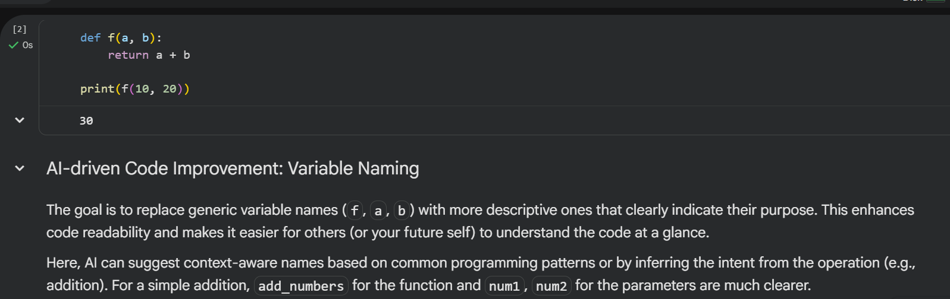

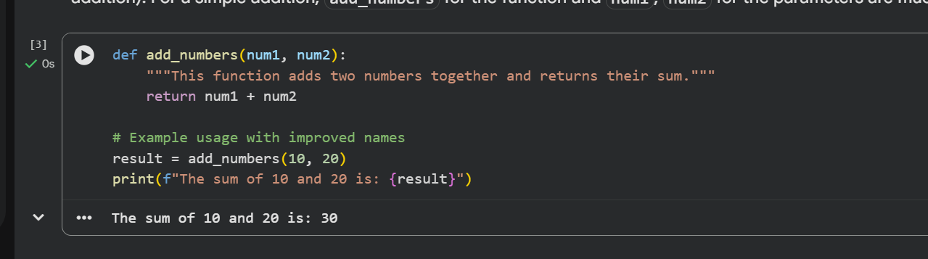

Task Description #2 – Missing Error Handling

Task: Use AI to add proper error handling.

Sample Input Code:

def divide(a, b):

return a / b

print(divide(10, 0))

Expected Output:

• Code with exception handling and clear error messages

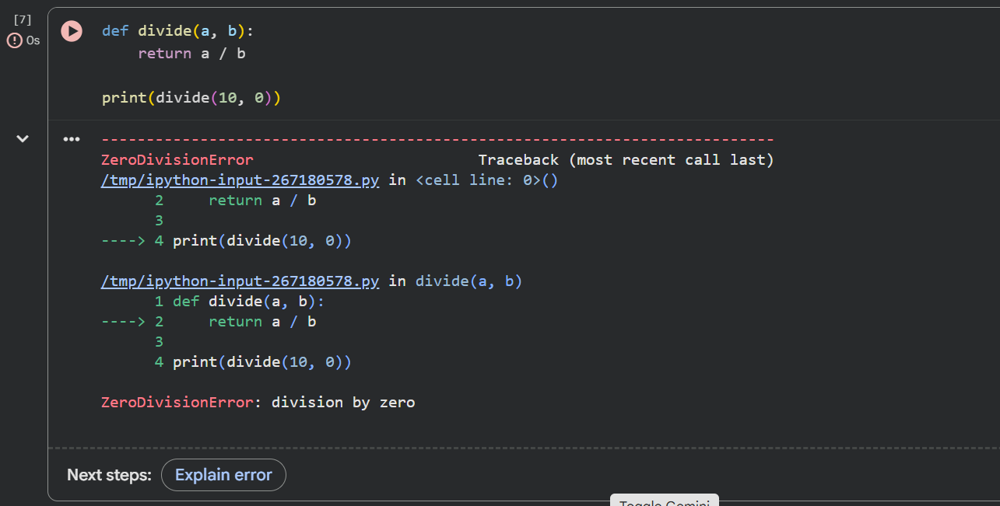

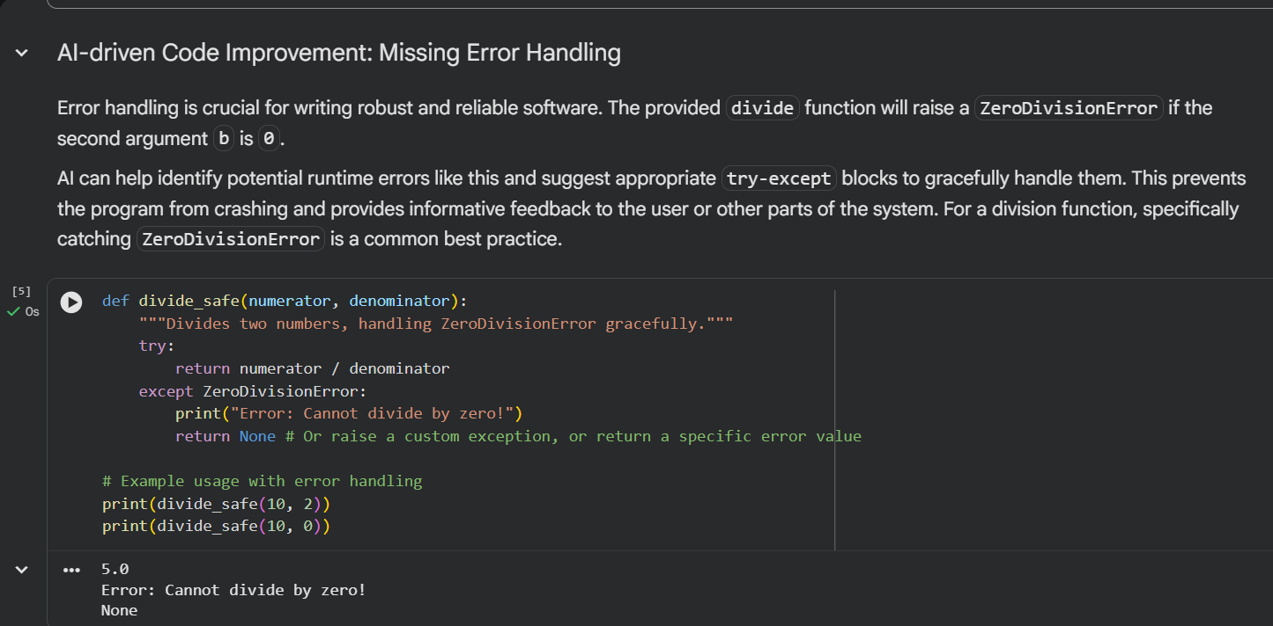

Task Description #3: Student Marks Processing System

The following program calculates total, average, and grade of a

student, but it has poor readability, style issues, and no error

handling.

marks=[78,85,90,66,88]

t=0

for i in marks:

t=t+i

a=t/len(marks)

if a>=90:

print("A")

elif a>=75:

print("B")

elif a>=60:

print("C")

else:

print("F")

Task:

• Use AI to refactor the code to follow PEP 8 standards.

• Add meaningful variable names, functions, and comments.

• Add basic input validation and documentation.

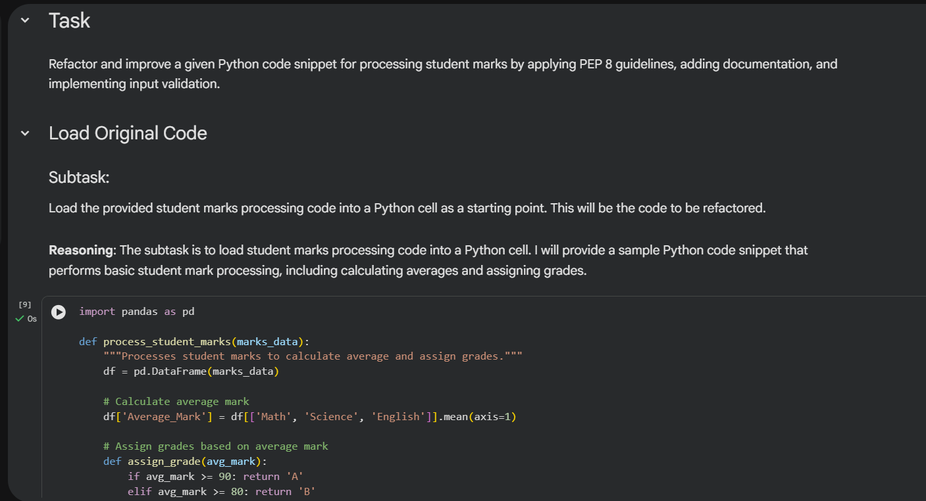

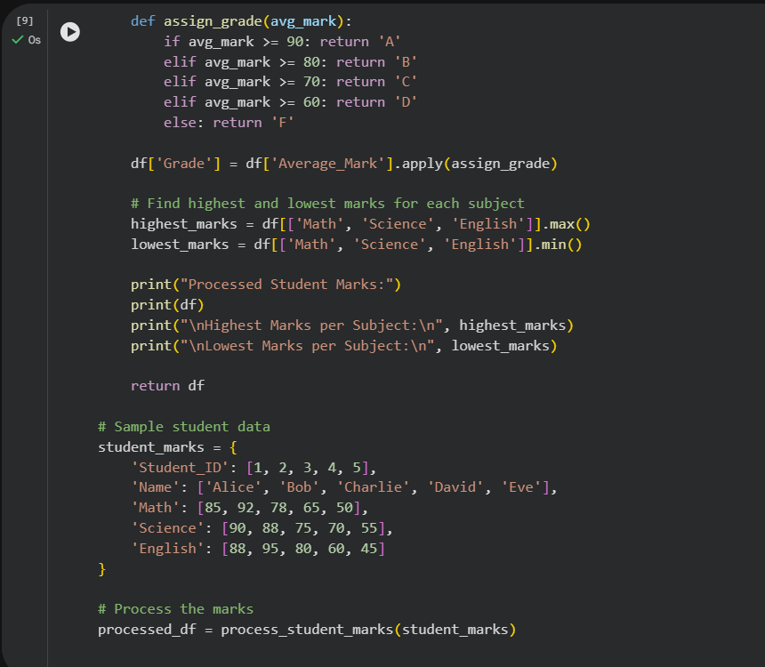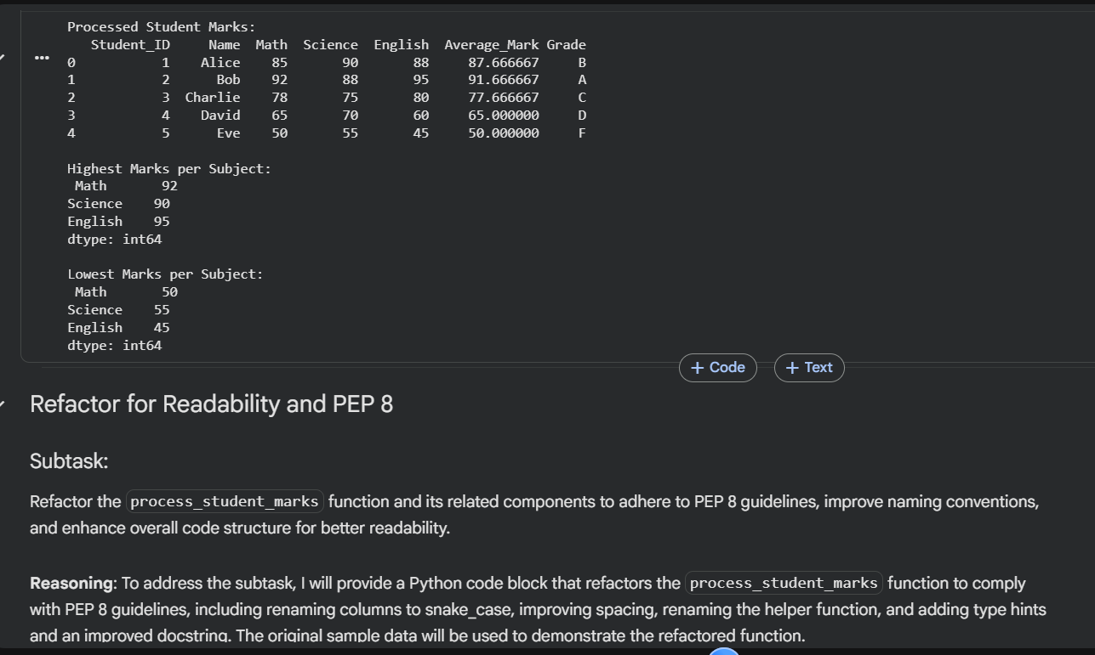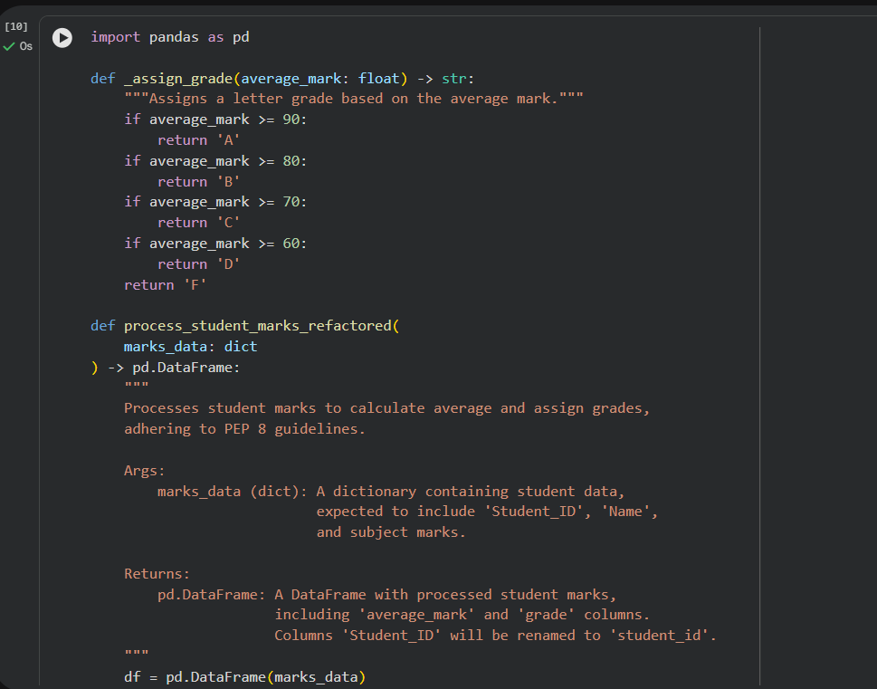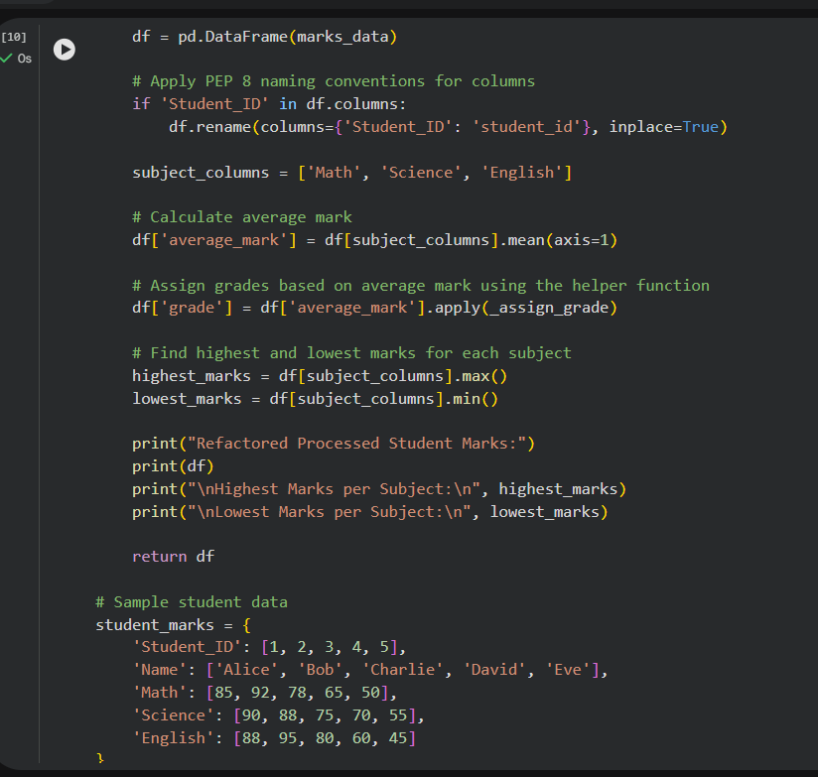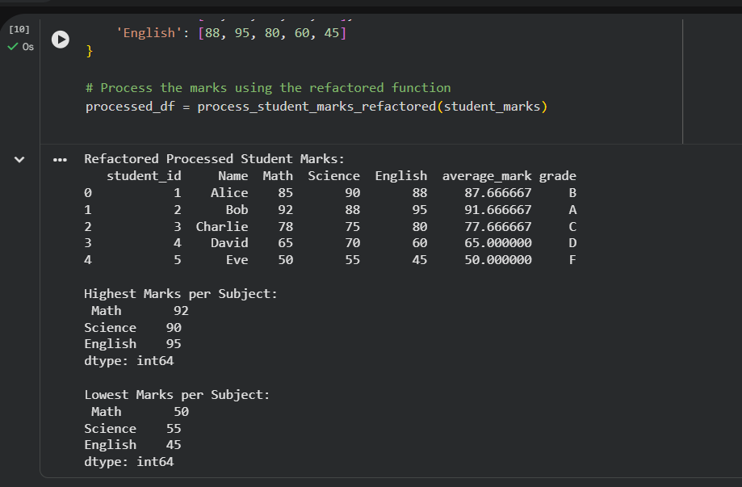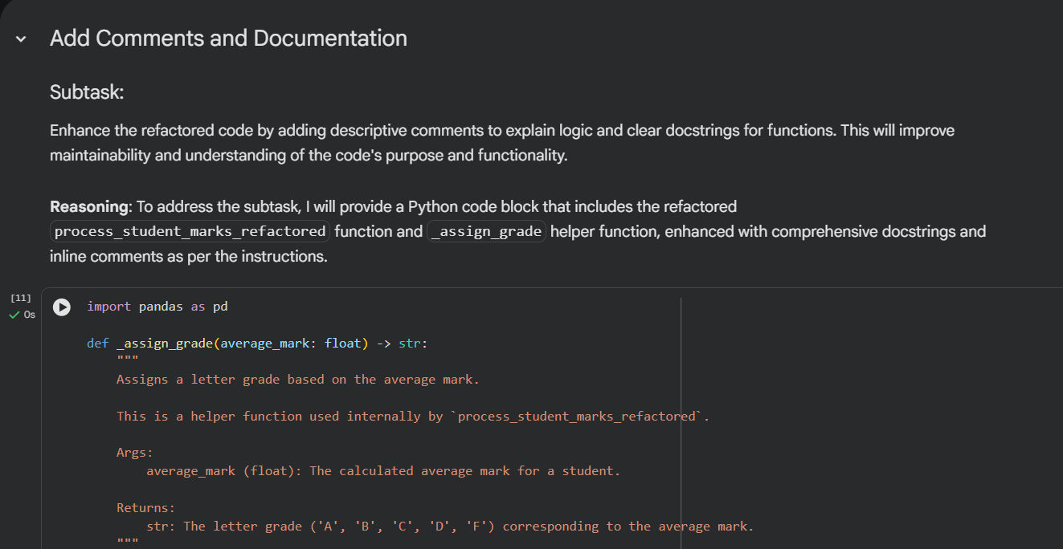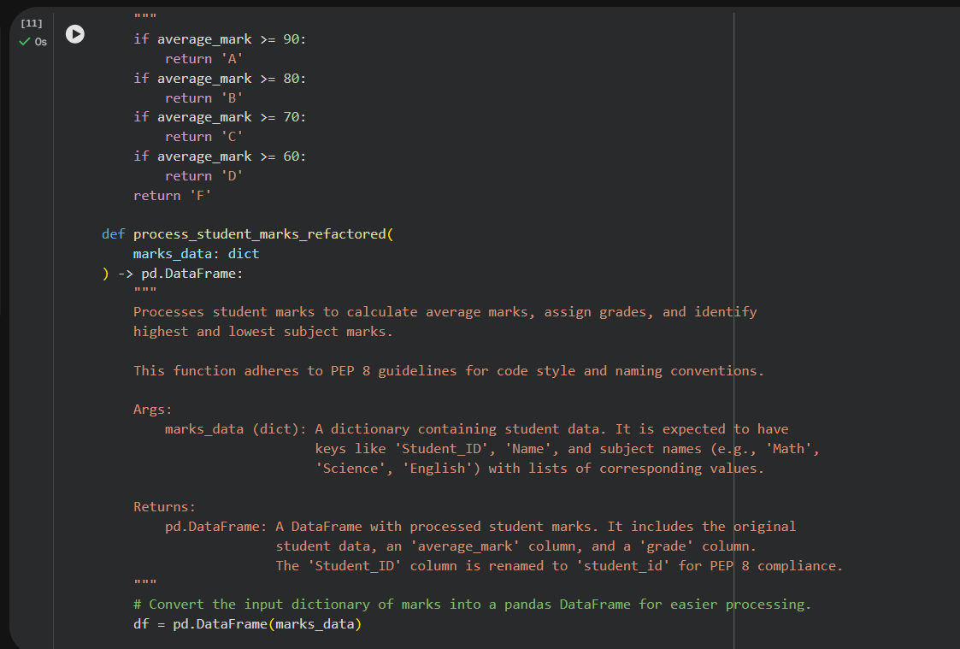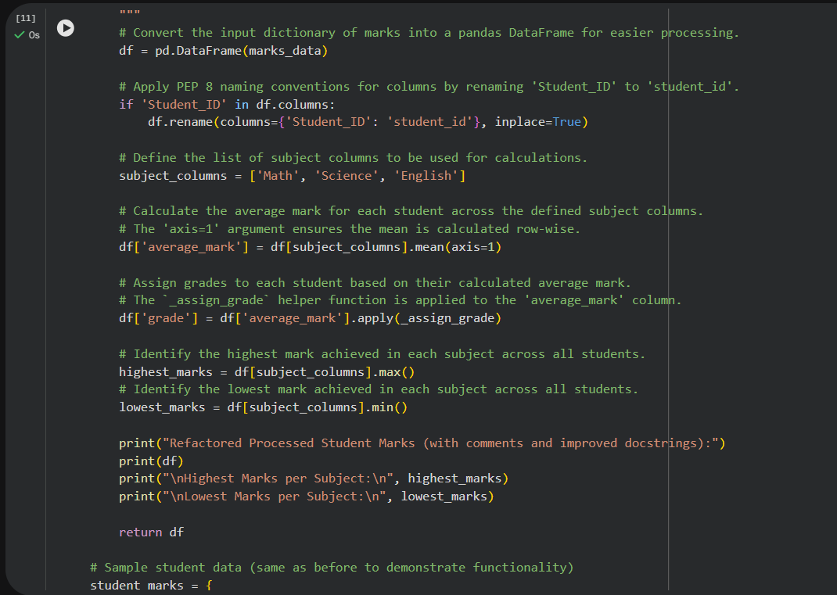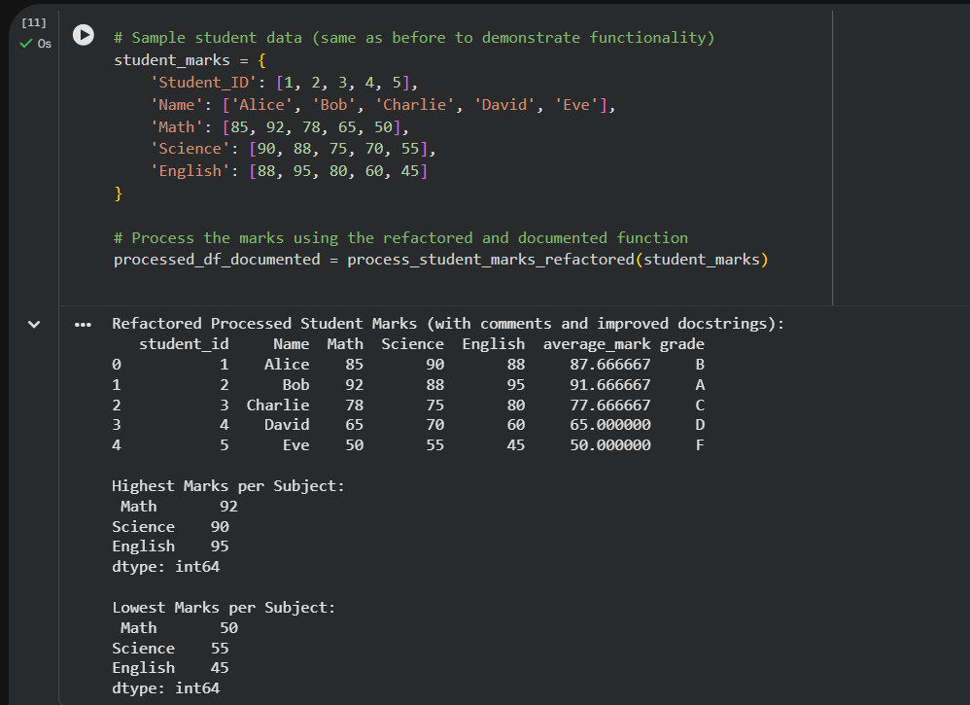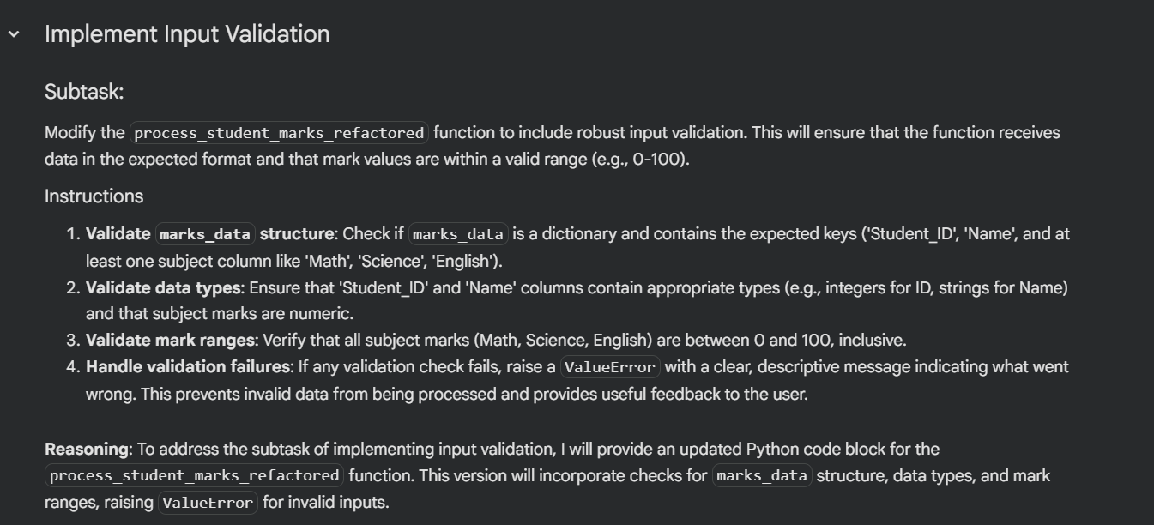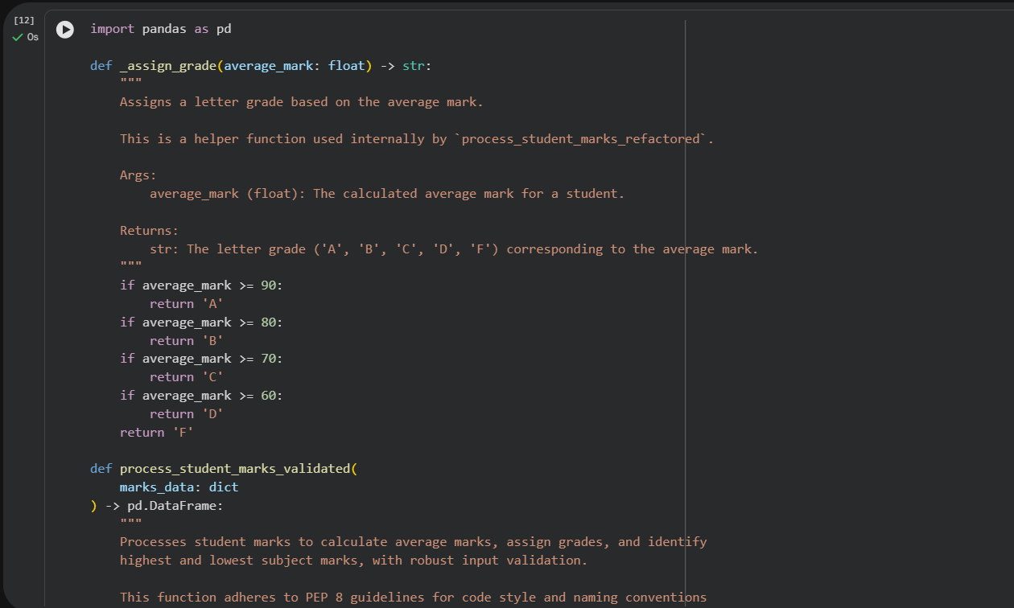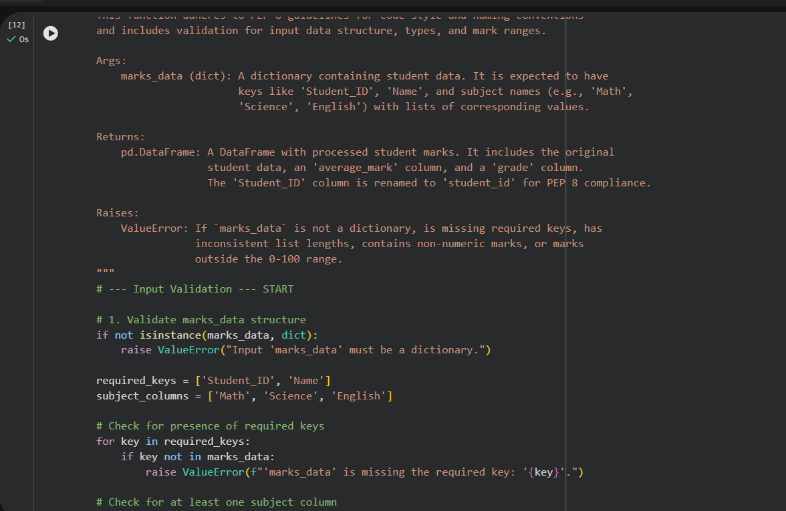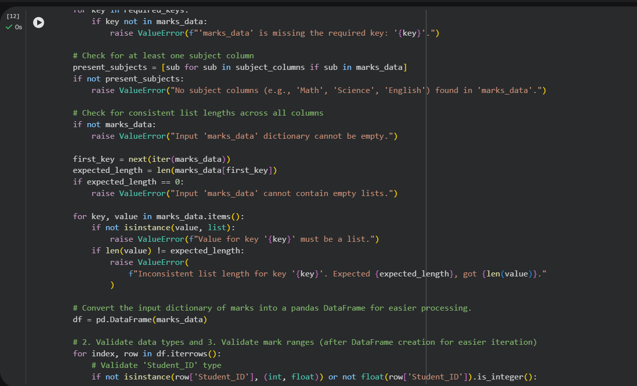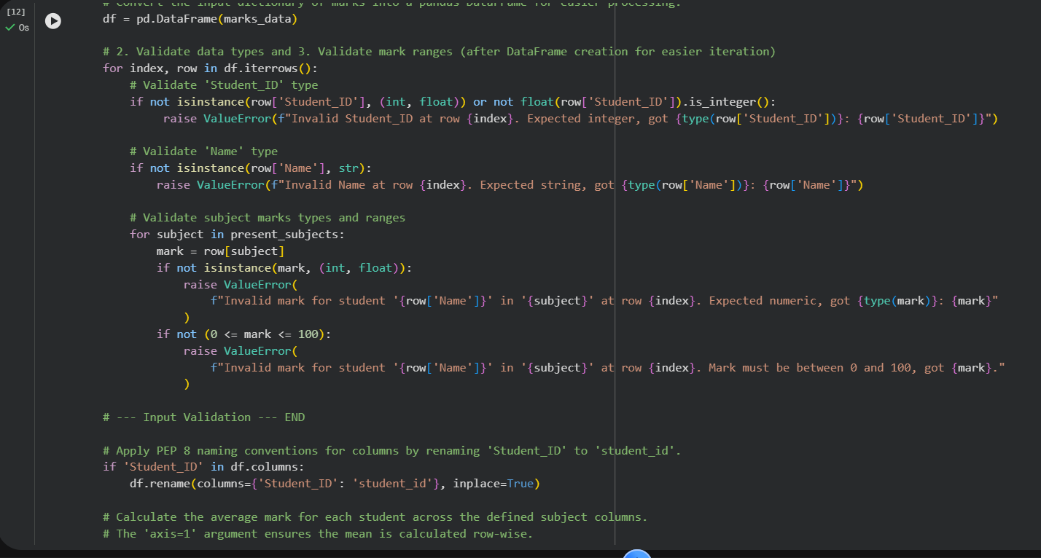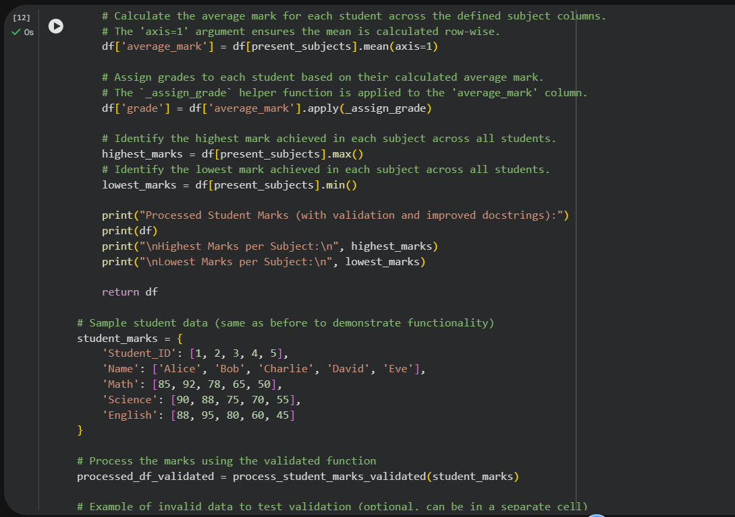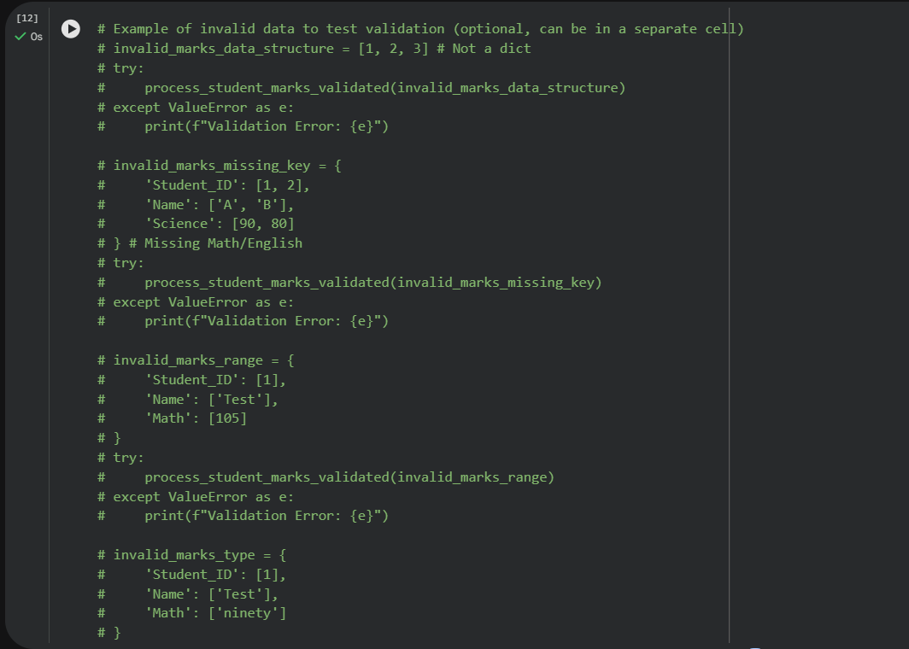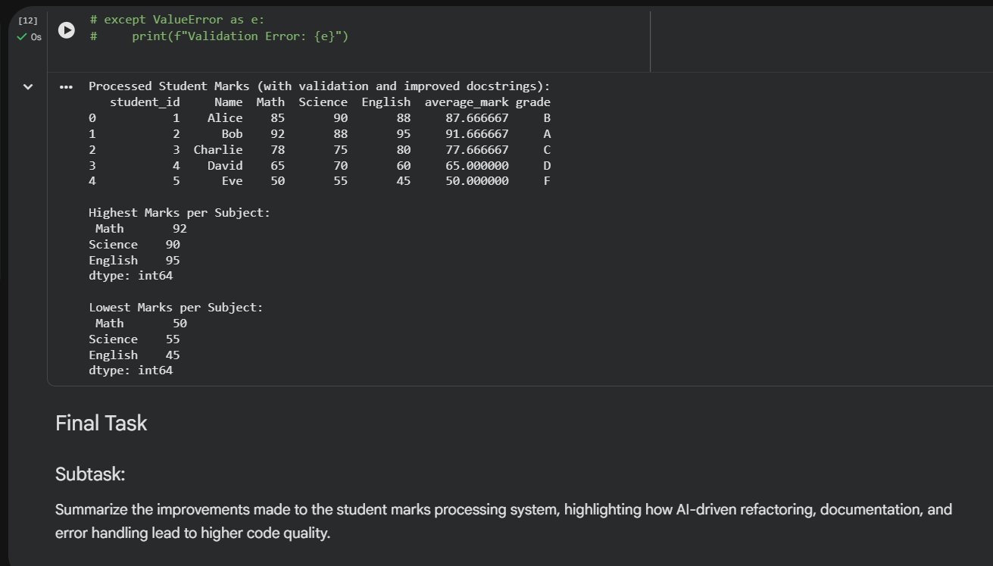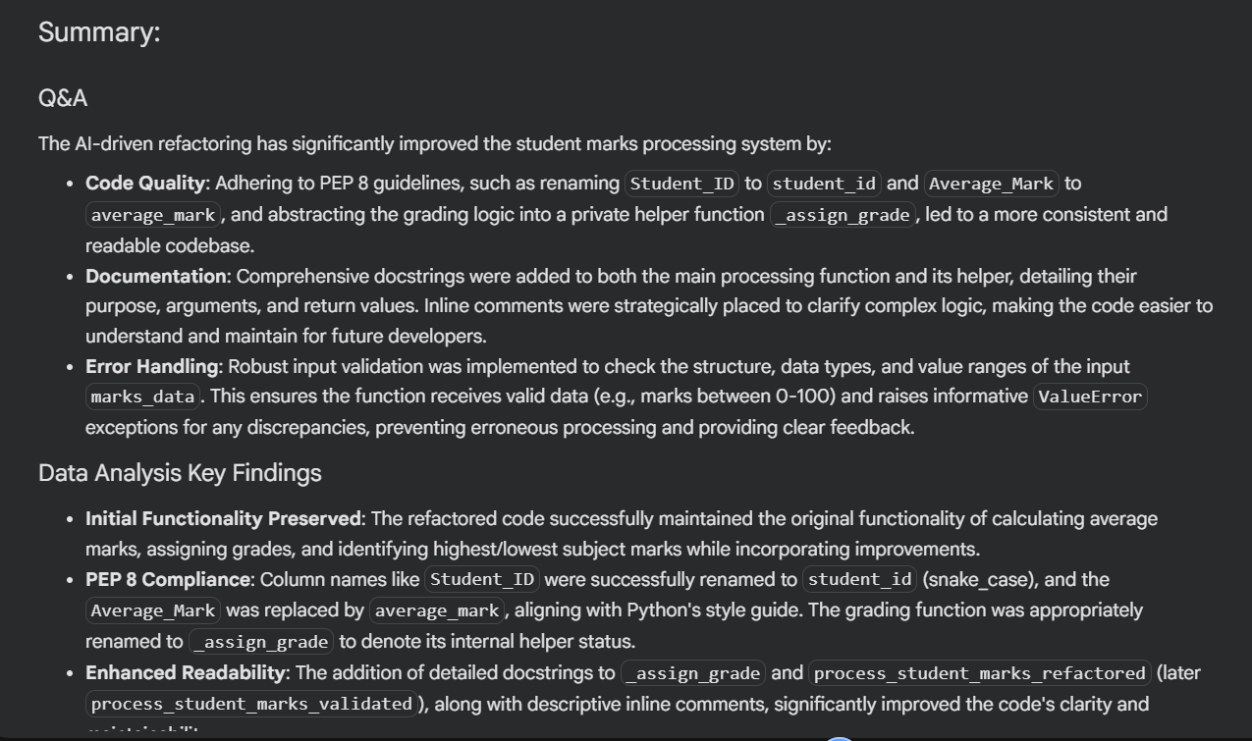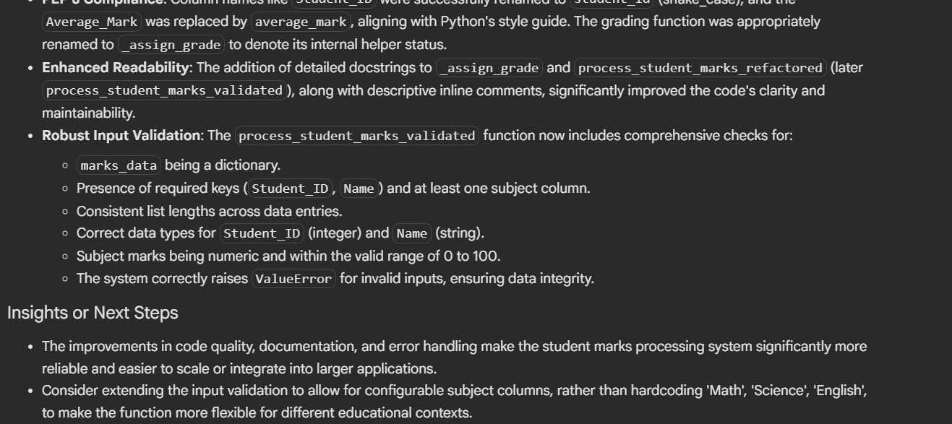

Task Description #4: Use AI to add docstrings and inline comments

to the following function.

def factorial(n):

result = 1

for i in range(1,n+1):

result *= i

return result

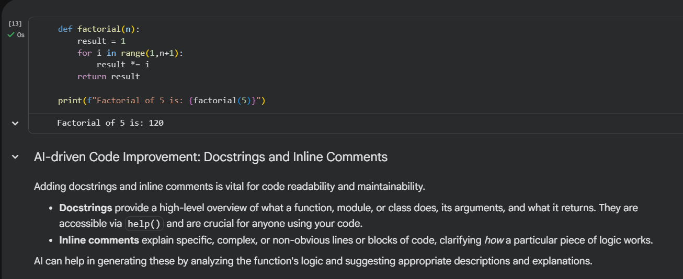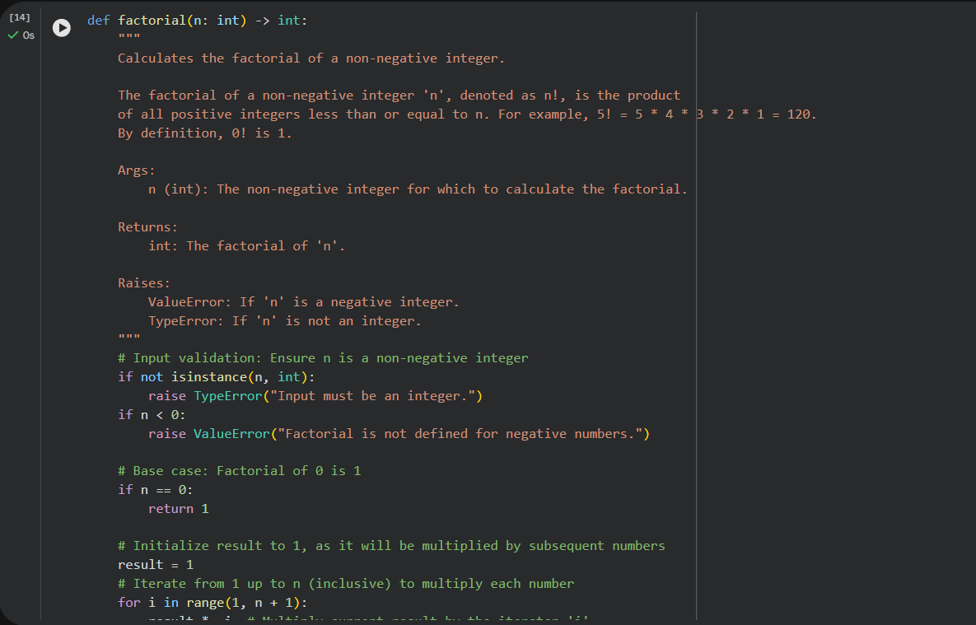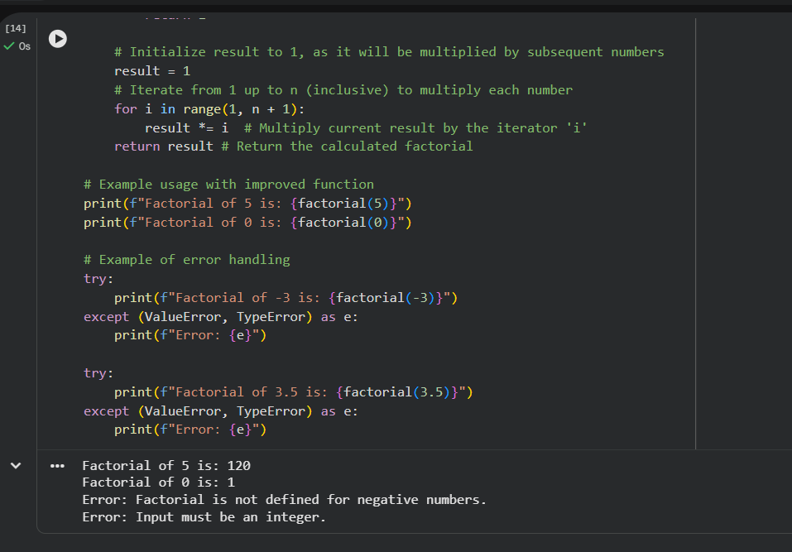

Task Description #5: Password Validation System (Enhanced)

The following Python program validates a password using only a

minimum length check, which is insufficient for real-world

security requirements.

pwd = input("Enter password: ")

if len(pwd) >= 8:

print("Strong")

else:

print("Weak")

Task:

1. Enhance password validation using AI assistance to include

multiple security rules such as:

o Minimum length requirement

o Presence of at least one uppercase letter

o Presence of at least one lowercase letter

o Presence of at least one digit

o Presence of at least one special character

2. Refactor the program to:

o Use meaningful variable and function names

o Follow PEP 8 coding standards

o Include inline comments and a docstring

3. Analyze the improvements by comparing the original and AI-

enhanced versions in terms of:

o Code readability and structure

o Maintainability and reusability

o Security strength and robustness

4. Justify the AI-generated changes, explaining why each added

rule and refactoring decision improves the overall quality of

the program.

